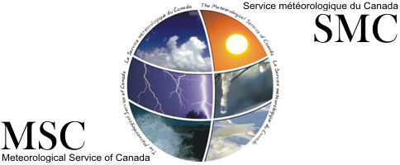

Green Lane

**THE PATTERSON MEDAL AWARD - 2019**

INSTRUCTIONS TO NOMINATORS

**A -** The Patterson Medal may be awarded to residents of Canada for distinguished service to meteorology.

The award may be made at any time during the life of the recipient for distinguished service over a protracted period of time or for recent outstanding achievement, both being equally eligible. No posthumous nominations will be considered.

The award will only be made when, in the opinion of the Patterson Medal Committee, there is a submission worthy of an award.

The evaluation of the nomination submission shall be made by the Patterson Medal Committee with due regard to the Terms of Reference of the Patterson Medal.

The nominee shall be judged on the basis of the information provided by the nominator and not from supplementary knowledge which the Committee members may possess.

**B -** Nominations for the award may be made by any resident of Canada.

The nominations should be received no later than **March 02, 2020**.

It is important that each nomination be supported by a concise, comprehensive statement indicating the merits of the contribution made by the nominee. The statement should be supported by documents, specifications, blueprints, or other explanatory material. The supporting information should include a 2 page résumé of the accomplishments of the individual and a statement indicating how these accomplishments were connected with the progress of the science of meteorology.

**C -** All communication should be addressed to:

**Jennifer Hebert**

Meteorological Service of Canada

351 St. Joseph Blvd., 8th Floor, Suite 8008

Gatineau, Quebec K1A0H3  
E-mail: Jennifer.hebert@canada.ca

Telephone: (819) 938-4388

**Note:** Sufficient supporting documentation is needed to properly assess each candidate’s contributions.